Future Skills College (FSC) is a full-time, one year, pre-apprenticeship pathway designed for students entering S5 and S6 in all Dundee City and five Angus Council secondary schools.

FSC seeks to secure student placements with local employers that could lead to full-time apprenticeship opportunities.

The majority of our students graduate into full time employment as apprentices. Our other leavers are guaranteed a full time D & A college course or choose another positive destination in employment.

FSC students continue on Dundee City Council or Angus school rolls. This means that parents/carers can still claim Child Benefit. Eligible students can also claim for Education Maintenance Allowance (EMA), free school meals and bus passes.

Proposed Future Skills College courses for 2021/22:
- Early Education and Childcare
- Plumbing
- Electrical
- Joinery

The three Future Skills College components:

- Studying at college

Students spend roughly two days per week on specially designed pre-apprenticeship D&A College courses in their chosen area of employment.

These courses lead to industry recognised SQA qualifications, making recruitment and support for new employees less complicated.

This should mean that they gain a flying start into their chosen professions.

- Completing school

FSC students also complete their secondary education at D&A College taking qualifications to the highest possible level, with a strong focus on Literacy and Numeracy as well as Health and Wellbeing, RE and PE.

Students take part in a wide range of activities to build their confidence, widen their experience and gain additional qualifications. This year students will participate in Growth Mind-set workshops, outdoor education activities as well as the Youth and Philanthropy Initiative.

All students have full Dundee and Angus College gym membership as an integral part of their studies.

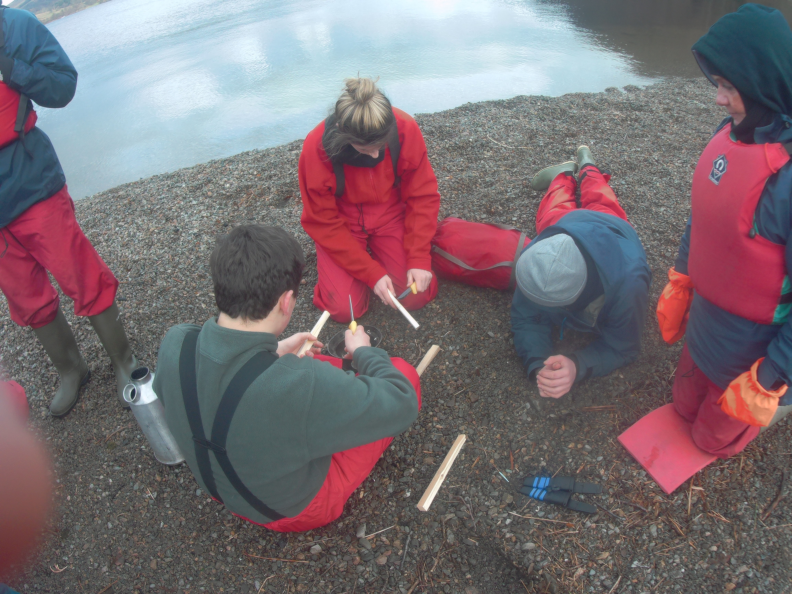
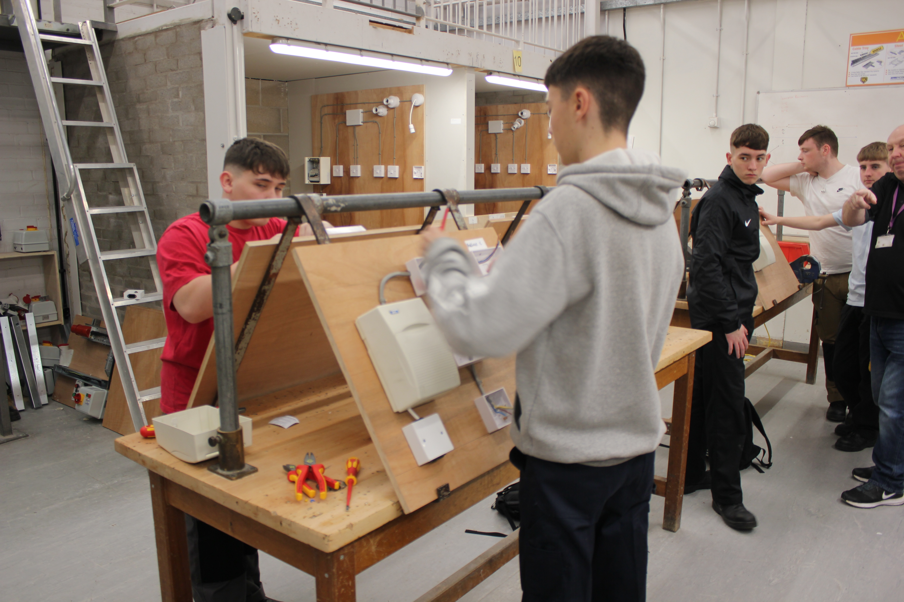

- Work placement

Students spend one day per week on work placement, with what we hope will be their future employer.

This gives students the opportunity to work with other staff, become used to the expectations of employers and be ready to start an apprenticeship fully prepared at the end of the course.

Employers value the approach taken by FSC as an opportunity to start building their own young workforce, making recruitment and support for new employees less complicated. Over the last three years these employers have included a wide range of construction companies, Dundee City Council, Dundee University, NHS Tayside, Hillcrest, DC Thomson, and Thornton’s Solicitors.

For further information
Graham Scott
Senior Pupil Support Officer
E: graham.scott@dundeecity.gov.uk
M: 07949 914987

