Name

Class Teacher

**Advanced Higher Physics**

**Rotational Motion**

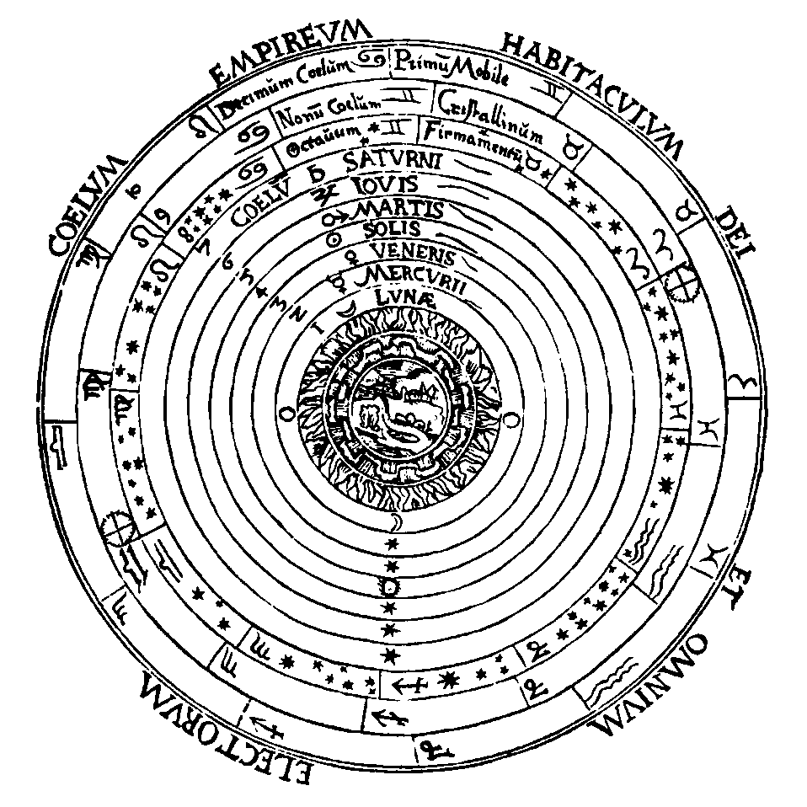

# KINEMATIC RELATIONSHIPS

Throughout this course calculus techniques will be used. These techniques are very powerful and a knowledge of integration and differentiation will allow a deeper understanding of the nature of physical phenomena.

Kinematics is the study of the motion of points, making no reference to what causes the motion.

The displacement s of a particle is the length **and** direction from the origin to the particle.

The displacement of the particle is a function of time: s = f(t)

Consider a particle moving along OX.



At time t + t particle passes Q.

### Velocity

average velocity vav =

However the **instantaneous** velocity is different, this is defined as :

v = lim (as t -> 0) v =

### Acceleration

velocity changes by v in time t

aav =

Instantaneous acceleration : a = lim (as t -> 0) a =

if a = then = . =

**Note:** a change in velocity may result from a change in direction (e.g. uniform motion in a circle - see later).

### Mathematical Derivation of Equations of Motion for Uniform Acceleration

a =

Integrate with respect to time:

=

 = a t + k

when t = 0  = u hence k = u   
 t = t  = v

integrate again : remember that v = = u + at

= +

s = u t + a t2 + k

apply initial conditions: when t = 0, s = 0 hence k = 0

Equations 1 and 2 can now be combined as follows: square both sides of equation 1

v2 = u2 + 2 u a t + a2 t2

v2 = u2 + 2 a [ u t + a t2]

(using equation 2)

A useful fourth equation is

**s = t ..... 4**

**Variable Acceleration**

If acceleration depends on time in a simple way, calculus can be used to solve the motion.

### Graphs of Motion

The slope or gradient of these graphs provides useful information. Also the area under the graph can have a physical significance.

### Displacement - time graphs

v = slope = instantaneous velocity.

Area under graph - no meaning.

### Velocity - time graphs

a = slope = instantaneous acceleration.

Also s =  Area under v-t graph gives the displacement.

### Calculations Involving Uniform Accelerations

Examples of **uniform** acceleration are:

* vertical motion of a projectile near the Earth’s surface, where the acceleration is g = 9.8 m s-2 vertically downwards
* rectilinear (i.e. straight line) motion e.g. vehicle accelerating along a road.

These have been covered previously; however a fuller mathematical treatment for projectiles is appropriate at this level.

Consider the simple case of an object projected with an initial velocity u at right angles to the Earth’s gravitational field - (locally the field lines may be considered parallel).



a = g, time to travel distance x across field = t

t =

apply y = uyt + a t2, uyt = 0 and a = g

y = . g .

y = [ . ] . x2

Now g and u are constants, y  x2 and we have the equation of a **parabola**.

The above proof and equations are **not** required for examination purposes.

# ANGULAR MOTION

The angular velocity of a rotating body is defined as the rate of change of angular displacement.

|  |  |
| --- | --- |
|  | where  (rad s-1) is the angular velocity   (rad) is the angular displacement |

The radian (rad) is a unit of angle: 180° =  rad

Angular acceleration,  = = unit of : rad s-2

We assume for this course that  is **constant**.

The derivation of theequations for angular motion are very similar to those for linear motion seen earlier.

**Angular Motion Relationships**

You will note that these **angular** equations have exactly the same form as the **linear** equations.

Remember that these equations only apply for **uniform** angular accelerations.

### Uniform Motion in a Circle

|  |  |
| --- | --- |
| Consider a particle moving with uniform speed in a circular path as shown opposite.   =  The rotational speed v is constant,  is also constant.  T is the period of the motion and is the time taken to cover 2 radians.   = but v = | (Note: s is the arc swept out by the particle   and s = r |

### Angular acceleration and linear tangential acceleration

The angular acceleration  = and the linear tangential acceleration at = , when the rotational speed v is *changing*.

Since v = r  then at any instant, then  = r giving

at = r 

where the direction of at is at a tangent to the circular path of radius r.

### Radial Acceleration

|  |  |  |
| --- | --- | --- |
|  |  |  |

The particle travels from A to B in time t and with speed v, thus | u | = | v | and

v = v + (−u) which is v = v − u

t = =

average acceleration, aav = =

= =

As ** tends to 0, aav tends to the instantaneous acceleration at point Q:

a = $\frac{v^{2}}{r}$. [$\lim_{θ→0}{\frac{\sin{θ}}{θ}}$] but [] = 1   
 when ** is small and is measured in radians sin ** = **.

since *v* = *r*

The **direction** of this acceleration is always towards the **centre** of the circle.

**Note**: This is **not** a uniform acceleration. Radial acceleration continuously changes direction and its magnitude changes is the speed of rotation changes.

This motion is typical of many **central force** type motions e.g. planetary motion, electrons ‘orbiting’ nuclei and electrons injected at right angles to a uniform magnetic field which will be covered later in the course.

Thus any object performing circular motion at uniform speed must have a constant **centre-seeking** or **central** force responsible for the motion.

### Central Force

Does a rotating body really have an inward acceleration (and hence an inward force)?

***Argument*** Most people have experienced the sensation of being in a car or a bus which is turning a corner at high speed. The feeling of being ‘thrown to the outside of the curve’ is very strong, especially if you slide along the seat. What happens here is that the friction between yourself and the seat is insufficient to provide the central force needed to deviate you from the straight line path you were following before the turn. In fact, instead of being thrown outwards, you are, in reality, continuing in a straight line while the car moves inwards. Eventually you are moved from the straight line path by the inward (central) force provided by the door.

### Magnitude of the Force

F = m a but a = or a = 2 r

Thus central force, since v = r .

### Examples

**1. A Car on a Flat Track**

If the car goes too fast, the car ‘breaks away’ at a tangent.The force of friction is not enough to supply an adequate central force.



**2.** **A Car on a Banked Track**

For tracks of similar surface properties, a car will be able to go faster on a banked track before going off at a tangent because there is a component of the normal reaction as well as a component of friction, Fr, supplying the central force.

The central force is R sin + Fr cos   which reduces to R sin  when the friction is zero. The analysis on the right hand side is for the friction Fr equal to **zero**.

|  |  |
| --- | --- |
| page8 | R is the ‘normal reaction’ force of the track on the car.  In the vertical direction there is no acceleration:  R cos = mg ........ 1  In the radial direction there is a central acceleration:  R sin = ........ 2  Divide Eq. 2 by Eq. 1:  tan  =  (This equation applies to all cases of ‘banking’ including aircraft turning in horizontal circles) |

# ROTATIONAL DYNAMICS

**Moment of a force**

The **moment** of a force is the **turning effect** it can produce.

Examples of moments are:

* using a long handled screwdriver to ‘lever off’ the lid of a paint tin,



* using a claw hammer to remove a nail from a block of wood or levering off a cap from a bottle.

Where F is the force and d is the perpendicular distance from the direction of the force to the turning point.

### Torque

For cases where a force is applied and this causes rotation about an axis, the moment of the force can be termed the **torque**.

|  |  |
| --- | --- |
|  | Consider a force F applied tangentially to the rim of a disc which can rotate about an axis O through its centre. The radius of the circle is r.  The torque T associated with this force F is defined to be the force multiplied by the radius r.  unit of T: newton metre (N m) |

Torque is a **vector** quantity. The direction of the torque vector is at right angles to the plane containing both r and F and lies along the axis of rotation. (In the example shown in the diagram torque, T, points out of the page).

A force acting on the rim of an object will cause the object to rotate; e.g. applying a push or a pull force to a door to open and close, providing it creates a non-zero resulting torque. The distance from the axis of rotation is an important measurement when calculating torque. It is instructive to measure the relative forces required to open a door by pulling with a spring balance firstly at the handle and then pulling in the middle of the door. Another example would be a **torque wrench** which is used to rotate the wheel nuts on a car to a certain ‘tightness’ as specified by the manufacturer.

An **unbalanced torque** will produce an **angular acceleration**. In the above diagram if there are no other forces then the force F will cause the object to rotate.

### Inertia

In linear dynamics an unbalanced force produces a linear acceleration. The magnitude of the linear acceleration produced by a given unbalanced force will depend on the mass of the object, that is on its inertia. The word inertia can be loosely described as ‘resistance to change in motion of an object’. Objects with a large mass are difficult to start moving and once moving are difficult to stop.

### Moment of Inertia

The moment of inertia I of an object can be described as its resistance to change in its angular motion. The moment of inertia I for rotational motion is analogous to the mass m for linear motion

The moment of inertia I of an object depends on the mass **and** the distribution of the mass about the axis of rotation.

For a mass m at a distance r from the axis of rotation the moment of inertia of this mass is given by the mass m multiplied by r2.

unit of I: kg m2

For example, a very light rod has two 0.8 kg masses each at a distance of 50 cm from the axis of rotation.



The moment of inertia of each mass is m r2 = 0.8 x 0.52 = 0.2 kg m2 giving a total moment of inertia I = 0.4 kg m2. Notice that we assume that all the mass is at the 50 cm distance. The small moment of inertia of the light rod has been ignored.

Another example is a hoop, with very light spokes connecting the hoop to an axis of rotation through the centre of the hoop and perpendicular to the plane of the hoop, e.g. a bicycle wheel. Almost all the mass of the hoop is at a distance R, where R is the radius of the hoop.   
Hence I = M R2 where M is the total mass of the hoop.

For objects where all the mass can be considered to be at the **same** distance from the axis of rotation this equation I = m r2 can be used directly.

However most objects do **not** have all their mass at a single distance from the axis of rotation and we must consider the distribution of the mass.

### Moment of inertia and mass distribution

|  |  |
| --- | --- |
|  | Consider a small particle of the disc as shown. This particle of mass m is at a distance r from the axis of rotation 0. |

The contribution of this mass to the moment of inertia of the whole object (in this case a disc) is given by the mass m multiplied by r2. To obtain the moment of inertia of the disc we need to consider all the particles of the disc, each at their different distances.

Any object can be considered to be made of n particles each of mass m. Each particle is at a particular radius r from the axis of rotation. The moment of inertia of the object is determined by the summation of all these n particles e.g.  (m r2). Calculus methods are used to determine the moments of inertia of extended objects. In this course, moments of inertia of extended objects, about specific axes, will be given.

It can be shown that the moment of inertia of a uniform rod of length L and total mass M through its centre is , but the moment of inertia of the same rod through its end is , i.e. four times bigger. This is because it is harder to make the rod rotate about an axis at the end than an axis through its middle because there are now more particles at a greater distance from the axis of rotation.

### Torque and Moment of Inertia

An **unbalanced torque** will produce an **angular acceleration**. As discussed above, the moment of inertia of an object is the opposition to a change in its angular motion. Thus the angular acceleration  produced by a given torque T will depend on the moment of inertia I of that object.

## Angular Momentum

The angular momentum L of a particle about an axis is defined as the **moment** of momentum.

|  |  |
| --- | --- |
|  | A particle of mass m rotates at  rad s-1 about the point O.  The linear momentum p = m v. The moment of p = m v r (r is perpendicular to v). |

Thus the angular momentum of this particle = m v r = m r2 , since v = r .

For a rigid object about a fixed axis the angular momentum L will be the summation of all the individual angular momenta. Thus the angular momentum L of an object is given by  (m r2  This can be written as   (m r2) since all the individual parts of the object will have the same angular velocity . Also we have I =  (m r2).

Thus the angular momentum of a rigid body is:

unit of L: kg m2 s-1.

Notice that the angular momentum of a rigid object about a fixed axis **depends** on the moment of inertia.

Angular momentum is a **vector** quantity. The **direction** of this vector is at right angles to the plane containing v (since p = m v and mass is scalar) and r and lies along the axis of rotation. For interest only, in the above example L is out of the page. (Consideration of the vector nature of T and L will not be required for assessment purposes.)

### Conservation of angular momentum

The **total** angular momentum before an impact will equal the **total** angular momentum after impact providing no external torques are acting.

You will meet a variety of problems which involve use of the conservation of angular momentum during collisions for their solution.

### Rotational Kinetic Energy

The rotational kinetic energy of a rigid object also depends on the moment of inertia. For an object of moment of inertia I rotating uniformly at  rad s-1 the rotational kinetic energy is given by:

### Energy and work done

If a torque T is applied through an angular displacement , then the work done = T 

Doing work produces a transfer of energy, T  = I   - I   (work done = Ek).

### Summary and Comparison of Linear and Angular Equations

***Quantity Linear Motion Angular Motion***

acceleration a ( a = r ) 

velocity v = u + a t (v = r )  = o +  t

displacement s = u t + a t2  = ot +  t2

momentum p = m v L = I 

kinetic energy m v2 I 2

Newton’s 2nd law F = m= m a T = I = I 

### Laws

Conservation of mAuA + mBuB = mAvA + mBvB IA□A + IB□B = IAA + IBB

momentum

Conservation of F . s = m v2 - m u2 T = I 2 - I o2

energy

### Some Moments of Inertia (for reference)

Thin disc about an axis through its centre I = M R2 R = radius of disc

and perpendicular to the disc.

Thin rod about its centre I = ML2 L = length of rod

Thin hoop about its centre I = M R2 R = radius of hoop

Sphere about its centre I = M R2 R = radius of sphere

Where M is the total mass of the object in each case.

### Objects Rolling down an Inclined Plane

When an object such as a sphere or cylinder is allowed to run down a slope, the Ep at the top, ( m g h), will be converted to both **linear** (m v2) and **angular** (I 2) kinetic energy.



An equation for the energy of the motion (assume no slipping) is given below.

m g h = I 2 + m v2

The above formula can be used in an experimental determination of the moment of inertia of a circular object.

### Example

*A solid cylinder is allowed to roll from rest down a shallow slope of length 2.0 m. When the height of the slope is 0.02 m, the time taken to roll down the slope is 7.8 s.*

*The mass of the cylinder is 10 kg and its radius is 0.10 m.*

*Using this information about the motion of the cylinder and the equation above, calculate the moment of inertia of the cylinder.*

### Solution

EP = m g h = 10 x 9.8 x 0.02 = 1.96 J

change in gravitational Ep = change in linear Ek + change in rotational Ek

m g h = ( m v2 - 0) + (I 2 - 0)

s = t

2.0 = x 7.8

v = = 0.513 m s-1

⬥ = = = 5.13 rad s-1

Ek(lin) = m v2 = x 10 (0.513)2 = 1.32 J

Ek(rot) = EP - Ek(lin)

I 2 = 1.96 - 1.32 = 0.64 J

I = =

I = 0.049 kg m2

## The Flywheel

### Example

*The flywheel shown below comprises a solid cylinder mounted through its centre and free to rotate in the vertical plane.*

|  |  |
| --- | --- |
|  | *Flywheel: mass = 25 kg*  *radius = 0.30 m.*  *Mass of hanging weight = 2.5 kg* |

*The hanging weight is released. This results in an angular acceleration of the flywheel. Assume that the effects of friction are negligible.*

*(a) Calculate the angular acceleration of the flywheel.*

*(b) Calculate the angular velocity of the flywheel just as the weight reaches ground level.*

Solution

(a) We need to know I, the moment of inertia of the flywheel: I = M R2

I = x 25 x (0.30)2 = 1.125 kg m2

consider the forces acting on the flywheel: W - FT = m a where m = 2.5 kg

24.5 - FT = 2.5 x 0.30      a = r 

FT            

Torque, T = FT x r = (24.5 - 0.75 ) x 0.30 and T = I      

thus           

   = 5.44 rad s-2

(b) To calculate the angular velocity we will need to know , the angular displacement for a length of rope 2.0 m long being unwound.

circumference = 2  r = 2  x 0.30

no. of revs = =

❑ = 2  x no. of revs = 2  x = 6.67 rad

o = 0 apply 2 = o2 + 2

⬥ = ? 2 = 0 + 2 x 5.44 x 6.67

 = 5.44 rad s-2 2 = 72.57

❑ = 6.67 rad  = 8.52 rad s-1

### Frictional Torque

### Example

*The friction acting at the axle of a bicycle wheel can be investigated as follows.*

*The wheel, of mass 1.2 kg and radius 0.50 m, is mounted so that it is free to rotate in the vertical plane. A driving torque is applied and when the wheel is rotating at 5.0 revs per second the driving torque is removed. The wheel then takes 2.0 minutes to stop.*

*(a) Assuming that all the spokes of the wheel are very light and the radius of the wheel is 0.50 m, calculate the moment of inertia of the wheel.*

*(b) Calculate the frictional torque which causes the wheel to come to rest.*

*(c) The effective radius of the axle is 1.5 cm. Calculate the force of friction acting at the axle.*

*(d) Calculate the kinetic energy lost by the wheel. Where has this energy gone?*

### Solution

(a) In this case I for wheel = MR2

I = 1.2 x (0.50)2 (M = 1.2 kg, R = 0.50 m )

I = 0.30 kg m2

(b) To find frictional torque we need the angular acceleration ( because  T     

     t = 120 s     

o = 5.0 r.p.s. =

= 31.4 rad s-1  = - 0.262 rad s-2

Now use T = I 

       x (-0.262)

T  **= -** 0.0786 N m

(c) Also T = r F (r = 1.5 cm = 0.015 m)

F = = - = - 5.24 N

i.e. negative value indicates force *opposing* motion.

(d) Ek(rot) = I o2

= x 0.30 x (31.4)2

= 148 J

When the wheel stops Ek(rot) = 0. This 148 J will have changed to heat in the axle due to the work done by the force of friction.

### Conservation of Angular Momentum

### Example

*A turntable, which is rotating on frictionless bearings, rotates at an angular speed of 15 revolutions per minute. A mass of 60 g is dropped from rest just above the disc at a distance of 0.12 m from the axis of rotation through its centre.*

**

*As a result of this impact, it is observed that the rate of rotation of the disc is reduced to 10 revolutions per minute.*

*(a) Use this information and the principle of conservation of angular momentum to calculate the moment of inertia of the disc.*

*(b) Show by calculation whether this is an elastic or inelastic collision.*

### Solution

(a) moment of inertia of disc = I

moment of inertia of 60 g mass = m r2 (treat as ‘particle’ at radius r)

= 0.06 x (0.12)2

Imass = 8.64 x 10-4 kg m2

initial angular velocity = o = 15 rev min-1 =

o = 1.57 rad s-1

final angular velocity =  = 10 rev min-1

= 1.05 rad s-1

total angular momentum before impact = total angular momentum after impact

I o = (I + Imass) 

I x 1.57 = (I + 8.64 x 10-4) x 1.05

0.52 I = 9.072 x 10-4

I = = 1.74 x 10-3 kg m2

(b) Ek before impact = I o2 = x 1.74 x 10-3 x (1.57)2 = 2.14 x 10-3 J

Ek after impact = 2 = x 2.60 x 10-3 x (1.05)2 = 1.43 x 10-3 J

Ek difference = 7.1 x 10-4 J

Thus the collision is **inelastic**.The energy difference will be changed to heat.