|  |
| --- |
|  |
| Dynamics and Space |
| National 4 Summary Notes |
|  |

|  |
| --- |
|  |

|  |  |  |  |
| --- | --- | --- | --- |
| **Speed and acceleration** |  |  |  |
| I can perform calculations involving the relationship between speed, distance, and time. |  |  |  |
| I can determine average and instantaneous speed. |  |  |  |
| I can interpret speed-time graphs to describe motion and can calculate distance travelled from them for objects which are speeding up, slowing down, stationary and moving with constant speed. |  |  |  |
| I can use the relationship involving acceleration, change in speed and time. |  |  |  |
| **Relationship between forces, motion and energy** |  |  |  |
| I can use Newton’s first law and the idea of balanced forces to explain constant speed. |  |  |  |
| I can use Newton’s second law to explain the movement of objects in situations involving constant acceleration. |  |  |  |
| I can perform calculations using the relationship between force, mass and acceleration in situations where only one force is acting. |  |  |  |
| I can describe & explain risks and benefits associated with space exploration including challenges of re-entry to a planet’s atmosphere. |  |  |  |
| I can explain the use of thermal protection systems to protect spacecraft on re-entry. |  |  |  |
| **Satellites** |  |  |  |
| I can describe the range of heights and functions of satellites in orbit around the earth, including geostationary and natural satellites. |  |  |  |
| I can describe & explain the dependence of period of orbit on height. |  |  |  |
| I can describe and explain the use of parabolic reflectors to send and receive signals. |  |  |  |
| I can use of the relationship between distance, speed and time in scenarios related to satellite communication. |  |  |  |
| I can describe the range of applications of satellite including telecommunications; weather monitoring; the use of satellites in environmental monitoring. |  |  |  |
| The use of satellites in developing our understanding of the global impact of mankind’s actions. |  |  |  |
| **Cosmology** |  |  |  |
| I can give a definition of planet, moon, star, solar systems, exo-planet, galaxy and universe. |  |  |  |
| I can describe the scale of the solar system and universe measured in light years. |  |  |  |
| I can explain the significance of space exploration and its impact on our understanding of the universe and planet Earth. |  |  |  |
| I can describe & explain the conditions required for an exo-planet to sustain life. |  |  |  |

**1.1 Motion**

**Speed**

**Speed**

**Speed** is the **distance** travelled by an object per **second** (usually expressed in metres per second, m/s or ms-1).

**Average Speed**

The average speed of an object is the average for the whole journey

(total distance travelled divided by time taken).

e.g. Sports presenters on T.V. measure the average speed of a footballer’s shot at goal

**Instantaneous Speed**

The instantaneous speedof an object is its speed at one particular point during the journey.

e.g. speed cameras measure the speed of a vehicle at a particular point in a journey to ensure that it is within the speed limit.

**Speed during a journey**

During a journey the instantaneous speed of a vehicle will change. For example at one point a car may be travelling along a street at 30 mph and when it is stopped at traffic lights its speed is 0 mph. These speeds can be very different from the average speed which may be something like 8 mph.

**Speed, Distance and Time Equation**

|  |  |  |
| --- | --- | --- |
| **Quantity** | **Symbol** | **SI Unit** |
| speed | v | m/s or ms-1 |
| distance | d | m |
| time | t | s |

From the definition: speed = distance

time

In symbol form: **v = d d = v t t = d**

**t v**

**Example: Calculate the average speed of a car which takes 3 minutes to travel 1000m.**

**List Equation** d = v t (as written in data book)

d= 1000 m **Substitute** 1000 = v x 180

v = ? **Answer & units** v = 5.56 ms-1

t = 3 minutes = 180 s

**Measuring Average Speed (v)**

* Measure distance (**d**) travelled with a measuring tape.
* Measure time (**t**) taken for the vehicle to travel the distance (d) with a timer.
* Use the equation v = d to calculate the average speed (**v**).

t

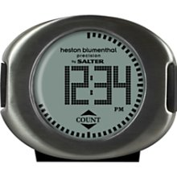

**timer**

**vehicle**

**d**

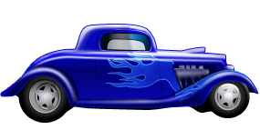

**Measuring Instantaneous Speed (v)**

* Measure the length of the vehicle (or card attached to the vehicle) (**d**) with a measuring tape.
* Measure time (**t**) taken for the vehicle to pass a point with a light gate connected to a timer.
* Use the equation v = d to calculate the instantaneous speed (**v**).

t

**Example: Calculate the speed of a car as it passes through the traffic lights. The car is 4m long and takes 0.75s to pass the traffic lights.**

**List Equation** d = v t

d= 4m **Substitute** 4 = v x 0.75

v = ? **Answer & units** v = 5.33ms-1

t = 0.75s

C:\Users\kslowey\AppData\Local\Microsoft\Windows\Temporary Internet Files\Content.IE5\0Q6UA0O6\MC900391202[1].wmf



**light**

**gate**



**light**

**gate**

**d**

**timer**

**Acceleration**

**Acceleration**

**Acceleration** is the **change in speed (or velocity)** every **second** and is measured in metres per second per second (ms-2).

It can be calculated using the formula:

acceleration = final velocity – initial velocity

time

In symbol form: **a = v – u**

**t**

A common form of the equation worth remembering

is **v = u + at**

**Example:**

**1. Calculate the acceleration of a vehicle travelling from rest to 12 ms-1 in 5 s.**

a = ? a = v - u

v = 12 ms-1 t

u = 0 (at rest) a = 12 - 0

t = 5 s 5

a = 2.4 ms-2

**2.** **A car accelerates at 4 ms-2 for 10 s from rest. Calculate the sped of the car after 10 s.**

a = 4 ms-2 a = v - u

v = ?t

u = 0 (at rest) v = u + at

t = 10 s v = 0 + (4 x 10)

v = 40 ms-1

**3.** **Calculate the deceleration of a train which travels from 30 ms-1 to 16 ms-1 in a time of 1**

**minute.**

a = ? a = v - u

v = 16 ms-1 t

u = 30 ms-1 a = 16 - 30

t = 1 minute = 60 s 60

a = - 0.47 ms-2 deceleration = 0.47 ms-2

|  |  |  |
| --- | --- | --- |
| **Quantity** | **Symbol** | **SI Unit** |
| acceleration | a | m/s/s or ms-2 |
| final velocity | v | ms-1 |
| Initial velocity | u | ms-1 |
| time | t | s |

**Graphs**

**Speed – Time Graphs**

A speed-time graph is a useful way of describing the motion of an object.

Since speed is a scalar quantity, a speed-time graph considers motion in one direction only.

The graphs below illustrate the 3 types of motion you will study.

**constant speed increasing speed decreasing speed**

**(constant acceleration) (constant deceleration)**

**The steeper the line (larger gradient) the greater the acceleration**

**Example: The motion of a car over 50 s is described in the speed-time graph below.**

1. **Calculate the acceleration of the car during the first 10 s.**
2. **Calculate the distance travelled by the car for the entire 50 s.**

**Solution**

1. a = ? a = v - u

v = 8 ms-1 t

u = 0 (at rest) a = 8 - 0

t = 10 s 10

a = 0.8 ms-2

1. **To calculate the distance travelled we cannot use d = vt as the speed is not constant throughout the journey.**

The distance travelled = area under the speed-time graph

Area 1 = ½ (10 x 8) = 40 (area of right angled triangle)

Area 2 = 30 x 8 = 240 (area of rectangle)

Area 3 = ½ (10 x 8) = 40 (area of right angled triangle)

Total area = 40 + 240 + 40 = 320 so distance travelled = 320m

v/ms-1

v/ms-1

v/ms-1

t/s

o

t/s

t/s

o

o

0

v/ms-1

8

10 40 50

t/s

0

**1.2 Forces**

**Effects of Forces**

**Forces** can only be detected by their effects.

They can **change**:

• the **shape** of an object e.g. squeezing plasticine

• the **speed** of an object e.g. kicking a football from rest

• the **direction of movement** of an object e.g. hitting a tennis ball with a racquet.

􀀀􀀀􀀀􀀀􀀀􀀀􀀀􀀀􀀀􀀀􀀀􀀀􀀀􀀀􀀀􀀀􀀀􀀀􀀀􀀀􀀀􀀀􀀀􀀀􀀀􀀀􀀀􀀀

􀀀􀀀􀀀􀀀􀀀􀀀􀀀􀀀􀀀􀀀􀀀􀀀􀀀􀀀􀀀􀀀􀀀􀀀􀀀􀀀􀀀􀀀􀀀􀀀􀀀􀀀􀀀􀀀

􀀀􀀀􀀀􀀀􀀀􀀀􀀀􀀀􀀀􀀀􀀀􀀀􀀀􀀀􀀀􀀀􀀀􀀀􀀀􀀀􀀀􀀀􀀀􀀀􀀀􀀀􀀀􀀀

􀀀􀀀􀀀􀀀􀀀􀀀􀀀􀀀􀀀􀀀􀀀􀀀􀀀􀀀􀀀􀀀􀀀􀀀􀀀􀀀􀀀􀀀􀀀􀀀􀀀􀀀􀀀􀀀

􀀀􀀀􀀀􀀀􀀀􀀀􀀀􀀀􀀀􀀀􀀀􀀀􀀀􀀀􀀀􀀀􀀀􀀀􀀀􀀀􀀀􀀀􀀀􀀀􀀀􀀀􀀀􀀀

􀀀􀀀􀀀􀀀􀀀􀀀􀀀􀀀􀀀􀀀􀀀􀀀􀀀􀀀􀀀􀀀􀀀􀀀􀀀􀀀􀀀􀀀􀀀􀀀􀀀􀀀􀀀􀀀

􀀀􀀀􀀀􀀀􀀀􀀀􀀀􀀀􀀀􀀀􀀀􀀀􀀀􀀀􀀀􀀀􀀀􀀀􀀀􀀀􀀀􀀀􀀀􀀀􀀀􀀀􀀀􀀀

* The force to be measured is applied to the hook which is attached to the spring.
* The force causes the spring to stretch.
* The greater the force, the greater the stretch of the spring and the further the marker moves across the scale.

hook

spring

marker

scale

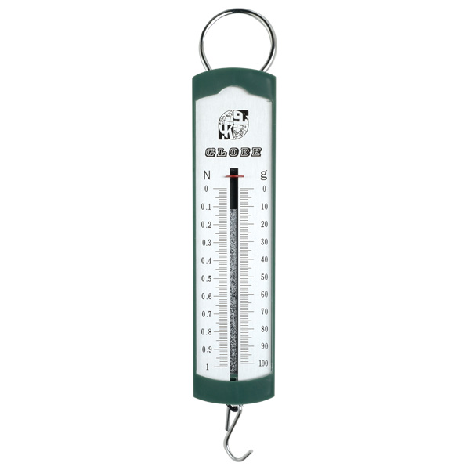

**Measurement of Forces**

Forces are measured in units called **newtons** (N). Force is a **Vector** quantity.

Forces can be measured with a newton balance. This instrument depends on the effect of a

force on the shape (length) of a spring.

􀀀􀀀􀀀􀀀􀀀􀀀􀀀􀀀􀀀􀀀􀀀􀀀􀀀􀀀􀀀􀀀􀀀􀀀􀀀􀀀􀀀􀀀􀀀􀀀􀀀􀀀􀀀􀀀

􀀀􀀀􀀀􀀀􀀀􀀀􀀀􀀀􀀀􀀀􀀀􀀀􀀀􀀀􀀀􀀀􀀀􀀀􀀀􀀀􀀀􀀀􀀀􀀀􀀀􀀀􀀀􀀀

􀀀􀀀􀀀􀀀􀀀􀀀􀀀􀀀􀀀􀀀􀀀􀀀􀀀􀀀􀀀􀀀􀀀􀀀􀀀􀀀􀀀􀀀􀀀􀀀􀀀􀀀􀀀􀀀

Force to be measured is applied here

**Friction**

**Introduction to Friction**

Friction is a **resistive** force, which **opposes** the direction of motion of an object. This means that it acts in the **opposite** direction to motion.

Friction acts between any two surfaces in contact.

When one surface moves over another, the force of friction acts between the surfaces and the size of the force depends on the surfaces, e.g. a rough surface will give a lot of friction.

Air friction is usually called **air resistance** or **drag**. It depends mainly on two factors:

• the shape and size of the object

• the speed of the moving object.

Air resistance **increases** as the speed of movement **increases** (as the object accelerates).

􀀀􀀀􀀀􀀀􀀀􀀀􀀀􀀀􀀀􀀀􀀀􀀀􀀀􀀀􀀀􀀀􀀀􀀀􀀀􀀀􀀀􀀀􀀀􀀀􀀀􀀀􀀀􀀀

􀀀􀀀􀀀􀀀􀀀􀀀􀀀􀀀􀀀􀀀􀀀􀀀􀀀􀀀􀀀􀀀􀀀􀀀􀀀􀀀􀀀􀀀􀀀􀀀􀀀􀀀􀀀􀀀

􀀀􀀀􀀀􀀀􀀀􀀀􀀀􀀀􀀀􀀀􀀀􀀀􀀀􀀀􀀀􀀀􀀀􀀀􀀀􀀀􀀀􀀀􀀀􀀀􀀀􀀀􀀀􀀀

􀀀􀀀􀀀􀀀􀀀􀀀􀀀􀀀􀀀􀀀􀀀􀀀􀀀􀀀􀀀􀀀􀀀􀀀􀀀􀀀􀀀􀀀􀀀􀀀􀀀􀀀􀀀􀀀

􀀀􀀀􀀀􀀀􀀀􀀀􀀀􀀀􀀀􀀀􀀀􀀀􀀀􀀀􀀀􀀀􀀀􀀀􀀀􀀀􀀀􀀀􀀀􀀀􀀀􀀀􀀀􀀀

􀀀􀀀􀀀􀀀􀀀􀀀􀀀􀀀􀀀􀀀􀀀􀀀􀀀􀀀􀀀􀀀􀀀􀀀􀀀􀀀􀀀􀀀􀀀􀀀􀀀􀀀􀀀􀀀

􀀀􀀀􀀀􀀀􀀀􀀀􀀀􀀀􀀀􀀀􀀀􀀀􀀀􀀀􀀀􀀀􀀀􀀀􀀀􀀀􀀀􀀀􀀀􀀀􀀀􀀀􀀀􀀀

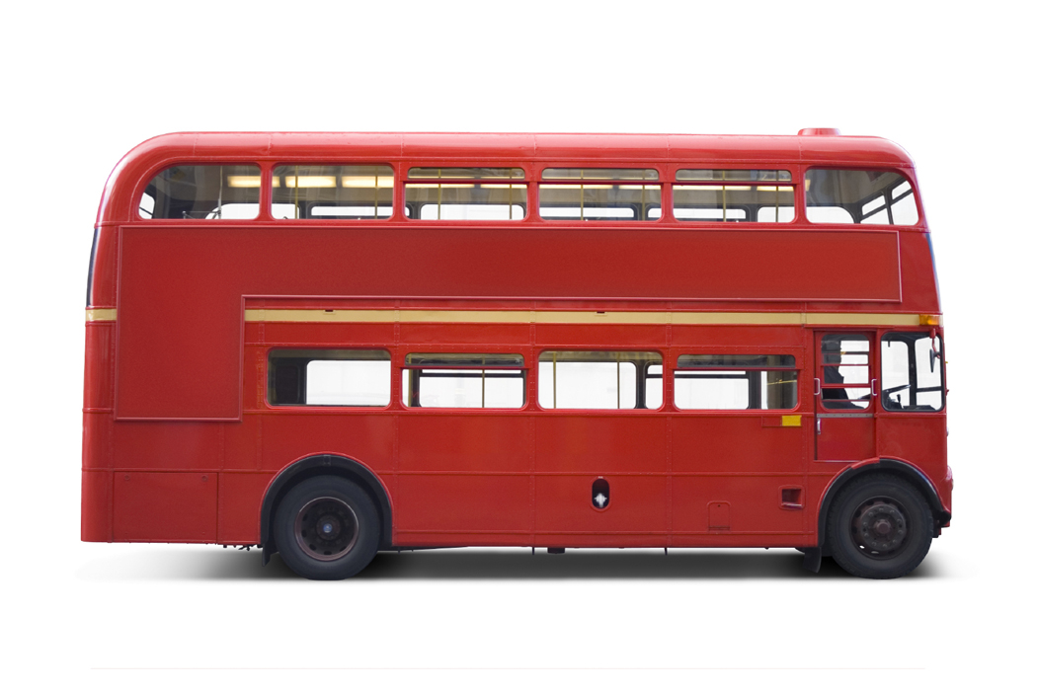

direction

of motion

friction

**Increasing Friction**

Where friction is used to **slow** an object down, it should be **increased**.

This can be achieved by:

• choosing surfaces which cause high friction e.g. sections of road before traffic lights

have higher friction than normal roads

• increasing the surface area and choosing a shape to increase air friction,

e.g. parachute.

**Decreasing Friction**

Where friction is making movement difficult, friction should be reduced.

This can be achieved by:

• lubricating the surfaces with oil or grease

• separating the surfaces with air, e.g. a hovercraft

• making the surfaces roll instead of slide, e.g. use ball bearings

• streamlining the shape of the object to reduce air friction (aerodynamic teardrop

shape).

􀀀􀀀􀀀􀀀􀀀􀀀􀀀􀀀􀀀􀀀􀀀􀀀􀀀􀀀􀀀􀀀􀀀􀀀􀀀􀀀􀀀􀀀􀀀􀀀􀀀􀀀􀀀􀀀

􀀀􀀀􀀀􀀀􀀀􀀀􀀀􀀀􀀀􀀀􀀀􀀀􀀀􀀀􀀀􀀀􀀀􀀀􀀀􀀀􀀀􀀀􀀀􀀀􀀀􀀀􀀀􀀀

􀀀􀀀􀀀􀀀􀀀􀀀􀀀􀀀􀀀􀀀􀀀􀀀􀀀􀀀􀀀􀀀􀀀􀀀􀀀􀀀􀀀􀀀􀀀􀀀􀀀􀀀􀀀􀀀

􀀀􀀀􀀀􀀀􀀀􀀀􀀀􀀀􀀀􀀀􀀀􀀀􀀀􀀀􀀀􀀀􀀀􀀀􀀀􀀀􀀀􀀀􀀀􀀀􀀀􀀀􀀀􀀀

􀀀􀀀􀀀􀀀􀀀􀀀􀀀􀀀􀀀􀀀􀀀􀀀􀀀􀀀􀀀􀀀􀀀􀀀􀀀􀀀􀀀􀀀􀀀􀀀􀀀􀀀􀀀􀀀

􀀀􀀀􀀀􀀀􀀀􀀀􀀀􀀀􀀀􀀀􀀀􀀀􀀀􀀀􀀀􀀀􀀀􀀀􀀀􀀀􀀀􀀀􀀀􀀀􀀀􀀀􀀀􀀀

􀀀􀀀􀀀􀀀􀀀􀀀􀀀􀀀􀀀􀀀􀀀􀀀􀀀􀀀􀀀􀀀􀀀􀀀􀀀􀀀􀀀􀀀􀀀􀀀􀀀􀀀􀀀􀀀

C:\Users\kslowey\AppData\Local\Microsoft\Windows\Temporary Internet Files\Content.IE5\50YLNRC0\MC900059411[1].wmf

[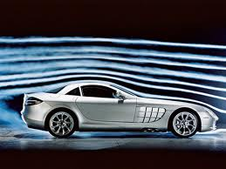](http://www.google.co.uk/imgres?q=aerodynamic&hl=en&biw=1152&bih=530&tbm=isch&tbnid=MwikFz-Bl40-EM:&imgrefurl=http://patrickji-sph3u.blogspot.com/2011/03/aerodynamics.html&docid=JreCeKYaj8OMFM&imgurl=http://4.bp.blogspot.com/-nFWoJzfDpZ4/TZKsH2dgfuI/AAAAAAAAALE/k3omN3QLd8E/s1600/slr.jpg&w=640&h=480&ei=ZYa7T6X9FYGt0QW1yZXSBw&zoom=1&iact=hc&vpx=127&vpy=69&dur=1514&hovh=194&hovw=259&tx=150&ty=124&sig=102108467074082338955&page=2&tbnh=163&tbnw=236&start=10&ndsp=15&ved=1t:429,r:5,s:10,i:173)

**Newton’s Laws of Motion (1 and 2)**

**Balanced Forces**

A force is a vector quantity because to describe it properly requires a direction as well as size.

Two forces which are **equal in size** which act in **opposite directions** are called **balanced forces.**

When the engine force = friction on the car the forces are balanced.

Balanced forces have the same effect as having **no** forces acting at all.

􀀀􀀀􀀀􀀀􀀀􀀀􀀀􀀀􀀀􀀀􀀀􀀀􀀀􀀀􀀀􀀀􀀀􀀀􀀀􀀀􀀀􀀀􀀀􀀀􀀀􀀀􀀀􀀀

􀀀􀀀􀀀􀀀􀀀􀀀􀀀􀀀􀀀􀀀􀀀􀀀􀀀􀀀􀀀􀀀􀀀􀀀􀀀􀀀􀀀􀀀􀀀􀀀􀀀􀀀􀀀􀀀

􀀀􀀀􀀀􀀀􀀀􀀀􀀀􀀀􀀀􀀀􀀀􀀀􀀀􀀀􀀀􀀀􀀀􀀀􀀀􀀀􀀀􀀀􀀀􀀀􀀀􀀀􀀀􀀀

􀀀􀀀􀀀􀀀􀀀􀀀􀀀􀀀􀀀􀀀􀀀􀀀􀀀􀀀􀀀􀀀􀀀􀀀􀀀􀀀􀀀􀀀􀀀􀀀􀀀􀀀􀀀􀀀

􀀀􀀀􀀀􀀀􀀀􀀀􀀀􀀀􀀀􀀀􀀀􀀀􀀀􀀀􀀀􀀀􀀀􀀀􀀀􀀀􀀀􀀀􀀀􀀀􀀀􀀀􀀀􀀀

􀀀􀀀􀀀􀀀􀀀􀀀􀀀􀀀􀀀􀀀􀀀􀀀􀀀􀀀􀀀􀀀􀀀􀀀􀀀􀀀􀀀􀀀􀀀􀀀􀀀􀀀􀀀􀀀

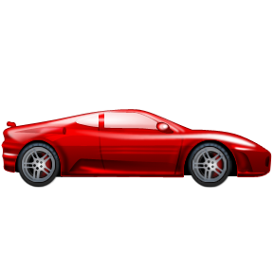

engine force

friction

**Newton’s 1st Law of Motion**

**An object will remain at rest or travel in a straight line at a constant velocity (or speed) if the forces are balanced.** 􀀀􀀀􀀀􀀀􀀀􀀀􀀀􀀀􀀀􀀀􀀀􀀀􀀀􀀀􀀀􀀀􀀀􀀀􀀀􀀀􀀀􀀀􀀀􀀀􀀀􀀀􀀀􀀀

􀀀􀀀􀀀􀀀􀀀􀀀􀀀􀀀􀀀􀀀􀀀􀀀􀀀􀀀􀀀􀀀􀀀􀀀􀀀􀀀􀀀􀀀􀀀􀀀􀀀􀀀􀀀􀀀

􀀀􀀀􀀀􀀀􀀀􀀀􀀀􀀀􀀀􀀀􀀀􀀀􀀀􀀀􀀀􀀀􀀀􀀀􀀀􀀀􀀀􀀀􀀀􀀀􀀀􀀀􀀀􀀀

􀀀􀀀􀀀􀀀􀀀􀀀􀀀􀀀􀀀􀀀􀀀􀀀􀀀􀀀􀀀􀀀􀀀􀀀􀀀􀀀􀀀􀀀􀀀􀀀􀀀􀀀􀀀􀀀

􀀀􀀀􀀀􀀀􀀀􀀀􀀀􀀀􀀀􀀀􀀀􀀀􀀀􀀀􀀀􀀀􀀀􀀀􀀀􀀀􀀀􀀀􀀀􀀀􀀀􀀀􀀀􀀀

􀀀􀀀􀀀􀀀􀀀􀀀􀀀􀀀􀀀􀀀􀀀􀀀􀀀􀀀􀀀􀀀􀀀􀀀􀀀􀀀􀀀􀀀􀀀􀀀􀀀􀀀􀀀􀀀

* If we consider the car moving in a straight line. If the engine force = friction, it will continue to move at a constant velocity (or speed) in the same direction.
* If the same car is stationary (not moving) and all forces acting on it are balanced (same as no force at all) the car will not move.



friction

engine force

**Free Body Diagrams**

We can use free body diagrams to analyse the forces on an object. This allows us to determine the motion of the object.

**Example: If the bus is travelling with an engine thrust of 12kN and all forces acting on the bus are balanced**

**a) calculate the size of the frictional force acting**

**b) determine the motion of the bus.**

**Solution a)** Draw the free body diagram

**b)** constant velocity (or speed) since the forces are balanced.

􀀀􀀀􀀀􀀀􀀀􀀀􀀀􀀀􀀀􀀀􀀀􀀀􀀀􀀀􀀀􀀀􀀀􀀀􀀀􀀀􀀀􀀀􀀀􀀀􀀀􀀀􀀀

􀀀􀀀􀀀􀀀􀀀􀀀􀀀􀀀􀀀􀀀􀀀􀀀􀀀􀀀􀀀􀀀􀀀􀀀􀀀􀀀􀀀􀀀􀀀􀀀􀀀􀀀􀀀􀀀

􀀀􀀀􀀀􀀀􀀀􀀀􀀀􀀀􀀀􀀀􀀀􀀀􀀀􀀀􀀀􀀀􀀀􀀀􀀀􀀀􀀀􀀀􀀀􀀀􀀀􀀀􀀀􀀀

􀀀􀀀􀀀􀀀􀀀􀀀􀀀􀀀􀀀􀀀􀀀􀀀􀀀􀀀􀀀􀀀􀀀􀀀􀀀􀀀􀀀􀀀􀀀􀀀􀀀􀀀􀀀􀀀

􀀀􀀀􀀀􀀀􀀀􀀀􀀀􀀀􀀀􀀀􀀀􀀀􀀀􀀀􀀀􀀀􀀀􀀀􀀀􀀀􀀀􀀀􀀀􀀀􀀀􀀀􀀀􀀀

􀀀􀀀􀀀􀀀􀀀􀀀􀀀􀀀􀀀􀀀􀀀􀀀􀀀􀀀􀀀􀀀􀀀􀀀􀀀􀀀􀀀􀀀􀀀􀀀􀀀􀀀􀀀􀀀

12kN Since the forces are balanced

friction = 12kN



friction

**Newton’s 2nd Law of Motion**

This law deals with situations when there is an unbalanced force acting on the object.

The velocity cannot remain constant and the acceleration produced will depend on:

* the mass (**m**) of the object **(a α 1/m) - if m increases a decreases and vice versa**
* the unbalanced force **(F) (a α F) - if F increases a increases and vice versa**

**This law can be summarised by the equation F = ma**

T

􀀀􀀀􀀀􀀀􀀀􀀀􀀀􀀀􀀀􀀀􀀀􀀀􀀀􀀀􀀀􀀀􀀀􀀀􀀀􀀀􀀀􀀀􀀀􀀀􀀀􀀀􀀀􀀀

􀀀􀀀􀀀􀀀􀀀􀀀􀀀􀀀􀀀􀀀􀀀􀀀􀀀􀀀􀀀􀀀􀀀􀀀􀀀􀀀􀀀􀀀􀀀􀀀􀀀􀀀􀀀􀀀

􀀀􀀀􀀀􀀀􀀀􀀀􀀀􀀀􀀀􀀀􀀀􀀀􀀀􀀀􀀀􀀀􀀀􀀀􀀀􀀀􀀀􀀀􀀀􀀀􀀀􀀀􀀀􀀀

􀀀􀀀􀀀􀀀􀀀􀀀􀀀􀀀􀀀􀀀􀀀􀀀􀀀􀀀􀀀􀀀􀀀􀀀􀀀􀀀􀀀􀀀􀀀􀀀􀀀􀀀􀀀􀀀

􀀀􀀀􀀀􀀀􀀀􀀀􀀀􀀀􀀀􀀀􀀀􀀀􀀀􀀀􀀀􀀀􀀀􀀀􀀀􀀀􀀀􀀀􀀀􀀀􀀀􀀀􀀀􀀀

**Force, Mass and Acceleration Equation**

A newton is defined as the force which makes a 1 kg mass accelerate at 1ms-2

|  |  |  |
| --- | --- | --- |
| **Quantity** | **Symbol** | **SI Unit** |
| unbalanced  force | F | N |
| mass | m | kg |
| acceleration | a | ms-2 |

From the definition: acceleration = unbalanced force

mass

In symbol form: **a = F F = ma m = F**

**m a**

**Example: Calculate the unbalanced force acting on a**

**10000 kg bus accelerating at 3.5 ms-2.**

F = ? F = ma

m = 10000 kg F = 10000 x 3.5

a = 3.5ms-2 F = 35000 N

**Weight and Mass**

**Weight**

**Weight is a force** caused by gravity acting on an object’s mass. On Earth, it measures the

pull of the Earth on the object. It is measured in **newtons (N)**.

**Mass**

**Mass** measures the amount of matter in an object. It is measured in **kilograms (kg).**

The value of mass does not change from place to place.

􀀀􀀀􀀀􀀀􀀀􀀀􀀀􀀀􀀀􀀀􀀀􀀀􀀀􀀀􀀀􀀀􀀀􀀀􀀀􀀀􀀀􀀀􀀀􀀀􀀀􀀀􀀀􀀀

􀀀􀀀􀀀􀀀􀀀􀀀􀀀􀀀􀀀􀀀􀀀􀀀􀀀􀀀􀀀􀀀􀀀􀀀􀀀􀀀􀀀􀀀􀀀􀀀􀀀􀀀􀀀􀀀

􀀀􀀀􀀀􀀀􀀀􀀀􀀀􀀀􀀀􀀀􀀀􀀀􀀀􀀀􀀀􀀀􀀀􀀀􀀀􀀀􀀀􀀀􀀀􀀀􀀀􀀀􀀀􀀀

􀀀􀀀􀀀􀀀􀀀􀀀􀀀􀀀􀀀􀀀􀀀􀀀􀀀􀀀􀀀􀀀􀀀􀀀􀀀􀀀􀀀􀀀􀀀􀀀􀀀􀀀􀀀􀀀

􀀀􀀀􀀀􀀀􀀀􀀀􀀀􀀀􀀀􀀀􀀀􀀀􀀀􀀀􀀀􀀀􀀀􀀀􀀀􀀀􀀀􀀀􀀀􀀀􀀀􀀀􀀀􀀀

**Weight, Mass and Gravitational Field Strength Equation**

Weight always acts vertically downwards. Its size does not just depend on the mass of the object, but on the strength of gravity at that place.

The strength of gravity in a particular place is called the **gravitational field strength (g)** and is defined as **the weight per unit mass**. It is measured in **Nkg-1. On Earth, g = 10 Nkg-1.**

|  |  |  |
| --- | --- | --- |
| **Quantity** | **Symbol** | **SI Unit** |
| weight | W | N |
| mass | m | kg |
| gravitational field strength | g | Nkg-1 |

From the definition:

gravitational field strength = weight

mass

In symbol form: **g = W W = mg m = W**

**m g**

**Example: A girl has a mass of 70 kg on Earth (g = 9.8 Nkg-1)**

1. **Calculate her weight on i) Earth and ii) the moon where g = 1.6 Nkg-1.**
2. **What is her mass on the moon?**

**Solution**

1. i) W = ? W = mg ii) W = ? W = mg

m = 70 kg W = 70 x 9.8 m = 70 kg W = 70 x 1.6

g = 9.8 Nkg-1 W = 686 N g = 1.6 Nkg-1 W = 112 N

1. m = 70 kg (mass does not change)

**1.3 Satellites and Projectiles**

**Satellites**

**Satellites - Introduction**

A **satellite** is an object which **orbits another object**.

The Moon is a natural satellite which orbits earth and Sputnik is a man made satellite as it was put into an orbit of the earth.

The **period** of a satellite is the **time** taken for the satellite to **complete one** orbit.

The **period** of a satellite depends on the **height of the satellite above the object** it is orbiting.

The **higher** the orbit of the satellite the **greater** the period and vice versa.

**Geostationary Satellite**

A **geostationary satellite** is a satellite which:

* has a period of 24 hours
* orbits at roughly 36000 km above the earth’s surface which is much higher than other satellites
* stays above the same point on the earth’s surface at all times.

**Satellite Communication**

**Ground stations** send microwave signals to the satellite using a curved dish transmitter to transmit a strong signal. At the satellite the signal is **collected** by a curved dish receiver, then

**amplified** and finally **retransmitted** (at a different frequency) back to the ground using

another curved dish transmitter. The transmitting and receiving aerials are placed at the **focal point of the curved reflector.**

**The signal is sent at a speed of 300 000 000 ms-1. This allows the equation d = vt to be used with satellite communication.**

**satellite**



**ground**

**station**



**ground**

**station**

**Satellite Communication – Parabolic (Curved) Reflectors**

**Receiving the signal Transmitting the signal**

**curved**

**reflector**

**curved**

**reflector**

**receiving**

**aerial**

**transmitting**

**aerial**

Curved reflectors are also used on certain transmitters to transmit a strong, parallel signal beam. In a dish transmitter the transmitting aerial is placed at the focus and the curved shape of the reflector produces a parallel signal beam.

Curved reflectors are used to increase the strength of a received signal from a satellite or

other source. The curved shape of the reflector collects the signal over a large area and brings it to a **focus**. The receiving aerial is placed at the focus so that it receives a strong signal.

**Applications of Satellites**

Satellites are being used by many countries in different ways. For example:

* **Sending a television or radio signal across the country or to another country**

The Olympic Games can be beamed around the world using satellite communication.

Three geostationary satellites, placed in orbit above the equator permits worldwide communication with satellites communicating with ground stations in different continents.

* **Navigation**

There are many Global Positioning Satellite (G.P.S) systems available to put in a car so that you don’t get lost. This uses the basic equation d = vt to establish your position.

* **Weather monitoring**

The **weather satellite** is a type of satellite that is primarily used to monitor the weather and climate of the Earth.

**Using Satellites to Monitor Global Change**

Global environmental change is one of the most pressing international concerns of the 21st century. For many years, various types of satellites have been used to detect and monitor worldwide changes including:

* the effects of global warming
* depletion in the ozone layer and
* large scale changes in land cover.

These changes have been down to both:

* natural occurrences and
* as a consequence of the impact of our actions.

Satellites which are used to monitor such events orbit at heights much smaller than 36000 km and do not stay above the same point on the Earth’s surface. This allows continuous observation and monitoring of the Earth's land, atmosphere, oceans and ice caps.

For example, the 2002 oil spill off the northwest coast of Spain was watched carefully by the European ENVISAT satellite, which, though not a weather satellite, flies an instrument (ASAR) which can see changes in the sea surface. It orbits at a height of approximately 800 km. With this information collected by the satellite, rescue teams and environmental agencies can attend the scene quickly and minimise the damage caused.

Other disasters, both natural and otherwise can be detected and monitored in a similar way.

**1.4 Cosmology**

**The Universe**

**Cosmic Definitions**

There are many different bodies moving around in the universe. Below is a list of some of them with a definition of what they are:

* **Star** A hot ball of matter which is undergoing nuclear fusion emitting

light. The sun is an example of a star.

* **Planet** A spherical ball of rock and / or gas which orbits a star.

Earth is an example of a planet.

* **Moon** A lump of matter which orbits a planet.

Our moon orbits Earth. Deimos which orbits Mars is another example of a moon.

* **Solar System** A solar system consists of a star and all the objects orbiting it as

well as all the material in that system.

Our Solar System includes the Sun together with the eight planets and their moons as well as all other celestial bodies that orbit the sun.

* **Galaxy** A large cluster of stars, some of which have planets orbiting them.

The Milky Way is an example of a galaxy.

* **Exoplanet** A planet outside our Solar System.

(or Extrasolar In 2009, there were between 220 and 350 reported exo planets

Planet) depending on the criteria used by the counting organisation.

* **The Universe** Consists of many Galaxies separated by empty space.

**Life on Exoplanets?**

If you consider the growing population and dwindling resources of our home planet, some scientists believe that finding exo planets capable of sustaining life should be a top priority.

Scientists need to consider the basic needs of life and if these needs can be delivered by an exo plant.

The basic needs for human life are:

* Oxygen
* Water
* Food
* Shelter
* Warmth.

In our search for a new home scientists need to identify an exo planet which has:

* A similar atmosphere to ours
* The potential to build shelter
* The potential to grow and nurture a sustainable food source.

The next problem once the exoplanet has been identified is how to get there!

**Light Year**

Contrary to the name, a light year is a measure of **distance** and **not** time.

**1 light year is the distance light travels in 1 year.**

**Light is an electromagnetic wave which travels at a speed of 300 000 000 ms-1.**

**Question**

**How far does light travel in one year?**

d = ? d = v t

v = 300 000 000 ms-1 d = 300 000000 x 31 536 000

t = 1 x 365 x 24 x 60 x 60 = 31 536 000 s d = 9 460 800 000 000 000 m

**one light year = 9 460 800 000 000 000 m**

As the distances in the universe are very large we need to use the term light year instead of metres or even miles. Below are distances you will be required to know.

Approximate distance from **Earth** to:

* **The Sun** – 0.000016 light years (or 8.3 light minutes)
* **Proxima Centauri** (nearest star outside the solar system) – 4.2 light years
* **Canis Major Dwarf** (nearest galaxy to the Milky Way) – 25000 light years
* The **edge of the known Universe** – 46 billion light years.

**1.5 Space Exploration**

**Heading into Space**

**What We Have Learned by Heading into Space?**

Read any debate about space exploration, and this question will invariably come up.

“Why should we be spending money exploring space when there are so many problems here on Earth that we need to solve first?”

It’s a tricky one.

One answer is that reaching for new heights often creates new solutions, new opportunities and elevates hope back on the ground.

We have learned so much about our own planet and the expanding universe by exploring space. If mankind had not explored space and used telescopes then we would not have found out the following about:

**The Earth**

* A greater understanding about the rotation of the Earth, the orbit of the Earth around the Sun and how this affects time on earth. e.g. one rotation of the Earth is one day, one orbit of the Sun by the Earth is one year etc.
* It has allowed meteorologists to predict and monitor of the weather. Satellites have been put into orbit to monitor the Earth’s weather systems and allows us to predict natural disasters e.g. tsunamis and hurricanes
* Allowed the monitoring of the polar ice caps and enabled a plan to be put in place to minimise their erosion and prepare for the consequences of the erosion i.e. rising water levels and the destruction of natural habitats for polar animals.

**The Universe**

* Greater understanding of the origin of the Universe
* The Universe is still expanding
* Estimate the age of the universe

Through exploration our understanding of the Universe has changed. There were a few misconceptions before our understanding shaped our belief of the expanding universe and the model of it we have today. Scientists at certain times thought:

* The Earth was thought to be flat - it's round.
* The Earth was thought to be the centre of the Universe (see diagram below) - it's not.
* The Sun was thought to be the centre of the Universe - it's not.
* The Milky Way was thought to be the centre of the Universe - It's not.
* The centre of the Universe was thought to have a definite location - it doesn't.

[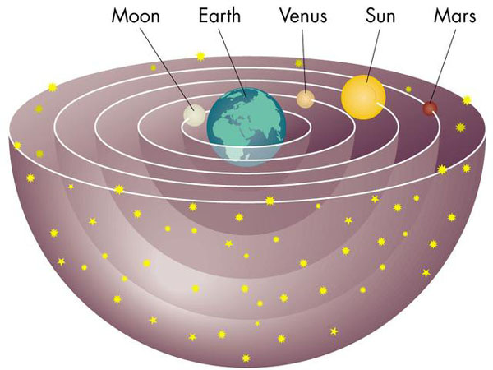](http://www.redorbit.com/media/uploads/2004/10/6_e1845fd7cbce79e3af2bb1c39d6ffe632.jpg)

**Answer : Hydrogen and Helium**.

**All** **spectral lines present in Hydrogen and Helium are present in the unknown star.**