Light Revision

Visible light is an electromagnetic wave. It is part of the electromagnetic spectrum. The only difference between visible light and other members of the electromagnetic spectrum is its wavelength.
Our eyes can only interpret a very narrow range of wavelengths, that is why our eyes can only pick up visible light.
Light travels in straight lines and does not need anything to carry it, so it can travel through the vacuum of space.
We can only see light if it directly enters our eyes. In order for us to see an object it must either emit or reflect light into our eyes.

The laser
A laser beam is a concentrated beam of light which travels in one direction only. We cannot see the beam unless it is directed at our eyes (which is EXTREMELLY dangerous) or reflected off of a surface and into our eyes.

Some safety rules for using a laser are:
- Never direct the beam into your own eyes or anyone else’s
- Make sure you direct the beam at a non-reflective surface.

Speed of light
Light travels much faster than sound. It travels in air and in a vacuum at 300 000 000 ms⁻¹ or 300 million metres per second. That means that it can travel 7 and a half times around the earth in one second!

The light year
Due to the vast distances in space, astronomers and physicists often use the unit, light year to describe them. A light year is the distance light can travel in one year. We can calculate the length of a light year in metres in the following way:

v = 300 000 000 ms⁻¹
t = (60 x 60 x 24 x 365) = 3156000 s *this calculation will give you the number of seconds in a year.

d = vt (where d = distance (m), v = speed (ms⁻¹) and t = time (s))
d = 300 000 000 x 3156000 = 9.46 x 10¹⁵ m

Reflection of light
When light ‘bounces’ off of a surface, such as a mirror, we say it is reflected.

The law of reflection
“The angle of incidence is the same as the angle of reflection”

The parabolic reflector
Curved, or parabolic reflectors can be very useful, as a receiver, they can direct light to a point called a focus. This can be used for receiving signals to give a very strong signal at the focus. The process can be reversed to direct a beam in a certain direction.

Refraction of light
Light travels more slowly in substances such as glass or water than in air or in a vacuum. Therefore, when light enters a different medium, it can be caused to change direction because of this change in speed.

Optical fibres
An optical fibre is a long, thin strand of glass which is used to transmit light signals from one place to another. In recent times, these have been used widely to replace copper cables for transmitting signals such as telephone calls and broadband signals.
Advantages of optical fibres over copper cables:
- Lighter and thinner
- Can carry up to 20 000 phone calls in a single strand
- Glass is much cheaper than copper
- No interference from surrounding cables
- More secure
- Less energy is lost in transmission

Disadvantages of optical fibres compared to copper cables
- Difficult to join and repair
Lenses
Lenses can be used to manipulate light and have many uses such as in cameras, our eyes and corrective lenses for eye defects such as short and long-sightedness.
- A concave lens is used to correct short-sightedness
- A convex lens is used to correct long-sightedness
A convex lens causes parallel rays to converge to a focus.

A concave lens causes parallel rays to diverge.

Colour
Our eyes interpret different wavelengths of light as different colours.
White light is a mixture of all the colours of the visible spectrum.

Red | Orange | Yellow | Green | Blue | Indigo | Violet

A prism can be used to split white light into its component colours
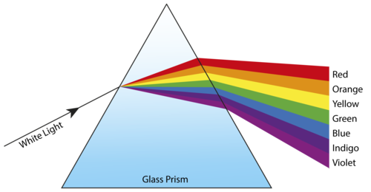

Colour mixing
